此篇文章属于我个人行为，和参与联名的校友无关。

此篇文章属于我个人行为，和参与联名的校友无关。

此篇文章属于我个人行为，和参与联名的校友无关。

昨晚校内匿名信源告诉我涉事导师可能以其他导师名义继续带研究生之后，我夜不能寐，显然校方情况通报里“停止涉事导师研究生招生资格”的处理措施是远远不够的，**只要他的教学和研究活动继续，就依然需要且能够和研究生接触，这些研究生的安全就得不到保障**。因此，目前当务之急就是立刻让王攀停止教学研究工作。

其实科研无非是为了国际权威杂志和机构发表论文，且王攀目前仍然拥有多个学术机构的会员和职务，但这些国际学术机构对涉嫌性骚扰/权力滥用的案件都非常敏感。在目前国内媒体相关报道纷纷被撤稿删稿、学校和涉事导师在舆论压力下岿然不动的情形之下，最有效的方式就是向这些国外学术机构施压，建议他们在公开调查结果出炉之前暂停和王攀的合作，让王攀个人付出代价。反正如果在如此情形之下，王攀还能悠哉悠哉地9月份去波兰参加CONFENIS学术会议，喝上一杯波兹南的啤酒，那一定是毫无正义可言的。

其实，多数对陶崇园事件坐视不理的人，并不是不知情，而是帮助陶争取争议的成本太高：微博转发和朋友圈转发，都会让他们觉得有负担。

我想，既然学校拒绝将王攀停职，那我们就有足够的道德立场来采取更直接的行动。我把争取正义的成本降到最低，只需要复制粘贴我的模板，向国外学术机构发邮件说明陶崇园事件的情况，一定能让这些机构意识到，必须在公开公平的调查结果出炉之前，暂停和王攀的合作。

**简单来说，就是复制粘贴，然后发邮件到指定邮箱就行。**

而且，既然学校使用的是公共资金，纳税人也完全有权利和道德义务监管资金使用。所以这次不只是校友，只要你关心此事并认同我停职王攀的主张，所有关心此事的网友都可以参与进来，我也会准备供校外朋友们使用的版本。

再多解释几句，我这样做不是偏激，更不是制造给“境外势力别有用心”的机会，而是不给王攀这种涉嫌性骚扰/权力滥用的人，以隐瞒实情在国际学术机构继续发表论文的机会，目标是保护王的研究生/潜在研究生不会在违背自己意愿的前提下被强迫为王攀工作，合情合理合法。

更何况我们所为完全符合程序正义，不是猎巫，没有要求国际学术机构永久性停止王攀发论文的资格，若公开公平的调查证明了王攀清白，国际学术机构大可以重新赋予王攀发论文的权利。何况这本来就是是国际学术机构应该遵循的高道德标准，也本应是学校和学术圈的道德责任，既然学校和学术圈没有人来做，那就由我们校友和纳税人来来提醒他们，何来偏激一说？

【翻译见文档尾部】

邮件给：【分别是王攀所在IEEE技术委员会共同主席、担任编辑的学术期刊主编和即将参加的国际学术会议组委会主席】

lxu@odu.edu；myu2@fsu.edu;[ifip-wcc@ifs.tuwien.ac.at](mailto:ifip-wcc@ifs.tuwien.ac.at)

抄送：【上述机构的公关部门】

corporate-communications@ieee.org;zhongkai.deng@ieee.org；[s.wolthers@elsevier.com](mailto:s.wolthers@elsevier.com)；

标题: Pan Wang has to go

邮件正文：

Co-chair of Enterprise Information Systems Technical Committe,IEEE SMC

Editor in Chief of Journal of Industrial Information Integration,

Organizational Coordination Chairperson of CONFENIS Conference 2018,

I am an alumni of Wuhan University of Technology(WUT). I am writing to you to remind you of a WUT professor, Pan Wang, is a suspect for a power abuse case ending up with suicidal of one graduate student, Chongyuan Tao. For the reputation of your organization, I sincerely suggest you suspend any acdemic cooperation with Wang until his case is fairly and transparently investigated and the decision has to be made public.

Following is an extraction of SupChina’s media report:

*Tao Chongyuan 陶崇园, a graduate student at Wuhan University of Technology’s School of Automation, jumped off the sixth floor of his dormitory building on March 26, reportedly after being mentally abused by his supervisor, Professor Wang Pan 王攀.*

*Tao’s sister, a doctor at the Huazhong University of Science and Technology (HUST), wrote on her Weibo account that her brother was coerced into assisting Wang with his personal affairs; under the request of Wang, Tao went to Wang’s apartment at night to prepare meals for him and do his laundry.*

*Wang allegedly applied for scholarships on behalf of Tao, who was obliged to “voluntarily” donate the fund in part or in full to Wang’s research institute. When Tao decided to apply for Ph.D. programs abroad and look for off-campus jobs, Wang threatened to expel him from the institute and prevent him from receiving a degree from the university.*

*Based on the screenshots of the chat history between Tao and Wang, the student more than once told Wang, “Father, I will always love you,” as the professor — who addressed Tao as “son” — requested.*

*“I can no longer tolerate this. I don’t know how to escape from Wang Pan,” Tao wrote to his mother, in what turned out to be his final words, before he jumped to his death.*

*According to The Paper, Wuhan University of Technology began investigating the incident on March 31. On April 4, alumni of WUT drafted an open letter calling for justice. The letter asks the university to guarantee transparency in the investigation, promise not to silence students, apologize to Tao’s family, and transfer the case to the police when necessary. The document was collaboratively authored on Shimo Docs, a platform similar to Google Docs. During Beijing’s crackdown of migrant workers in November 2017, netizens used the platform to offer assistance to evicted victims (that link is no longer visible to the public for unknown reasons).*

*Students have expressed dissatisfaction toward the school’s administration on the university’s Tieba forum, the Chinese counterpart of Reddit. Some students organized an event on campus to commemorate Tao, but the university allegedly stopped the memorial, labeling it an act of illegal assembly. One student questioned, “Why is the commemoration an act of illegal assembly, while plaza dancing isn’t?”*

On April 8th, authority of WUT posted a Situation Notice on Weibo and claimed Pan Wang has only done  ‘some activities unrelated to academic research’ and would ‘suspend his qualification of continuing to recruit more graduate students ’. This notice was taken by the victim’s family as evading the essence of the case and demand suspension of his qualification as professor.

I am informed that Chinese academia has the custom that though a graduate may be accepted by one professor, he/she may end up with working for another professor. I am concerning that this loophole could potentially be abused by Pan Wang so that he could continue what he has done with the victim. So continual of his current research activity will jeopodize his current and future graduate students. Suspension of any acdemic cooperation will be the first step towards justice.

Since WUT authority is yet to disqualify Wang’s tenure, I strongly suggest the your organization maintain its consistently high moral standards and suspend Pan Wang’s involvement, until his case is thoroughly and transparently investigated.

I am also informed that multiple renown international media are following this story. I sincerely hope you make the right decision before it becomes a public relation disaster.

*This email is a part of a series of #justicefortcy# actions. It may the first but definitely not the last. Apology for same email from different alumni. But we have to make sure our voices heard.

Sincerely,

【你名字的英文拼写，先名后姓，比如 Wei Zhou】

WUT Alumni,

Relevant media reports

<https://supchina.com/2018/04/05/graduate-students-suicide-raises-questions-about-the-professor-student-power-dynamic-on-chinese-campuses/>

<http://www.bbc.com/zhongwen/simp/chinese-news-43621581> [in Mandarin]

【-----------正文结束，复制至此--------------】

 【社会公众版，翻译见文档尾部】

邮件给：【分别是王攀所在IEEE技术委员会共同主席、担任编辑的学术期刊主编和即将参加的国际学术会议组委会主席】

lxu@odu.edu；myu2@fsu.edu;[ifip-wcc@ifs.tuwien.ac.at](mailto:ifip-wcc@ifs.tuwien.ac.at)

抄送：【上述机构的公关部门】

corporate-communications@ieee.org;zhongkai.deng@ieee.org；[s.wolthers@elsevier.com](mailto:s.wolthers@elsevier.com)；

标题: Pan Wang has to go

邮件正文：

Co-chair of Enterprise Information Systems Technical Committe,IEEE SMC

Editor in Chief of Journal of Industrial Information Integration,

Organizational Coordination Chairperson of CONFENIS Conference 2018,

I am a Chinese citizen and concerned member of the society. I am writing to you to remind you of a WUT professor, Pan Wang, is a suspect for a power abuse case ending up with suicidal of one graduate student, Chongyuan Tao. For the reputation of your organization, I sincerely suggest you suspend any acdemic cooperation with Wang until his case is fairly and transparently investigated and the decision has to be made public.

Following is an extraction of SupChina’s media report:

*Tao Chongyuan 陶崇园, a graduate student at Wuhan University of Technology’s School of Automation, jumped off the sixth floor of his dormitory building on March 26, reportedly after being mentally abused by his supervisor, Professor Wang Pan 王攀.*

*Tao’s sister, a doctor at the Huazhong University of Science and Technology (HUST), wrote on her Weibo account that her brother was coerced into assisting Wang with his personal affairs; under the request of Wang, Tao went to Wang’s apartment at night to prepare meals for him and do his laundry.*

*Wang allegedly applied for scholarships on behalf of Tao, who was obliged to “voluntarily” donate the fund in part or in full to Wang’s research institute. When Tao decided to apply for Ph.D. programs abroad and look for off-campus jobs, Wang threatened to expel him from the institute and prevent him from receiving a degree from the university.*

*Based on the screenshots of the chat history between Tao and Wang, the student more than once told Wang, “Father, I will always love you,” as the professor — who addressed Tao as “son” — requested.*

*“I can no longer tolerate this. I don’t know how to escape from Wang Pan,” Tao wrote to his mother, in what turned out to be his final words, before he jumped to his death.*

*According to The Paper, Wuhan University of Technology began investigating the incident on March 31. On April 4, alumni of WUT drafted an open letter calling for justice. The letter asks the university to guarantee transparency in the investigation, promise not to silence students, apologize to Tao’s family, and transfer the case to the police when necessary. The document was collaboratively authored on Shimo Docs, a platform similar to Google Docs. During Beijing’s crackdown of migrant workers in November 2017, netizens used the platform to offer assistance to evicted victims (that link is no longer visible to the public for unknown reasons).*

*Students have expressed dissatisfaction toward the school’s administration on the university’s Tieba forum, the Chinese counterpart of Reddit. Some students organized an event on campus to commemorate Tao, but the university allegedly stopped the memorial, labeling it an act of illegal assembly. One student questioned, “Why is the commemoration an act of illegal assembly, while plaza dancing isn’t?”*

On April 8th, authority of WUT posted a Situation Notice on Weibo and claimed Pan Wang has only done  ‘some activities unrelated to academic research’ and would ‘suspend his qualification of continuing to recruit more graduate students ’. This notice was taken by the victim’s family as evading the essence of the case and demand suspension of his qualification as professor.

I am informed that Chinese academia has the custom that though a graduate may be accepted by one professor, he/she may end up with working for another professor. I am concerning that this loophole could potentially be abused by Pan Wang so that he could continue what he has done with the victim. So continual of his current research activity will jeopodize his current and future graduate students. Suspension of any acdemic cooperation will be the first step towards justice.

Since WUT authority is yet to disqualify Wang’s tenure, I strongly suggest the your organization maintain its consistently high moral standards and suspend Pan Wang’s involvement, until his case is thoroughly and transparently investigated.

I am also informed that multiple renown international media are following this story. I sincerely hope you make the right decision before it becomes a public relation disaster..

*This email is a part of a series of #justicefortcy# actions. It may the first but definitely not the last. Apology for same email from different of us. But we have to make sure our voices heard.

Sincerely,

【你名字的英文拼写，先名后姓，比如 Wei Zhou】

Relevant media reports

<https://supchina.com/2018/04/05/graduate-students-suicide-raises-questions-about-the-professor-student-power-dynamic-on-chinese-campuses/>

<http://www.bbc.com/zhongwen/simp/chinese-news-43621581> [in Mandarin]

【-----------正文结束，复制至此--------------】

附资料：

*IEEE王攀资料页截图和链接

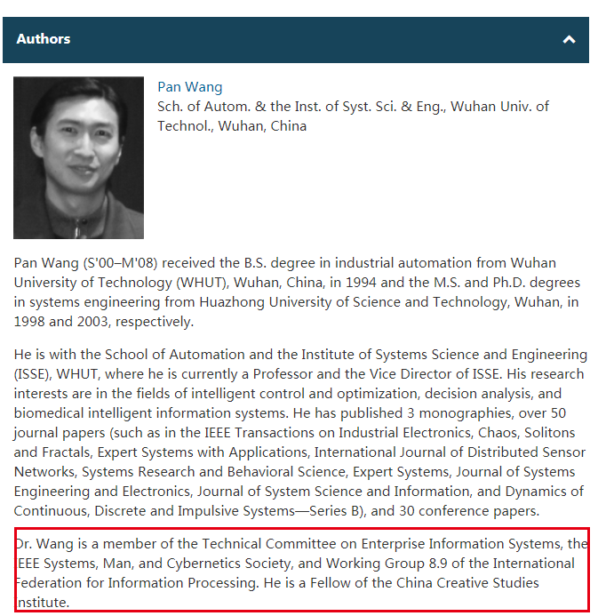

<https://ieeexplore.ieee.org/document/6547983/authors?anchor=943102970&ctx=authors>

<http://www.ieeesmc.org/technical-activities/systems-science-and-engineering/enterprise-information-systems>

**《Industrial Information Integration》杂志编委会成员名单中的王攀资料截图

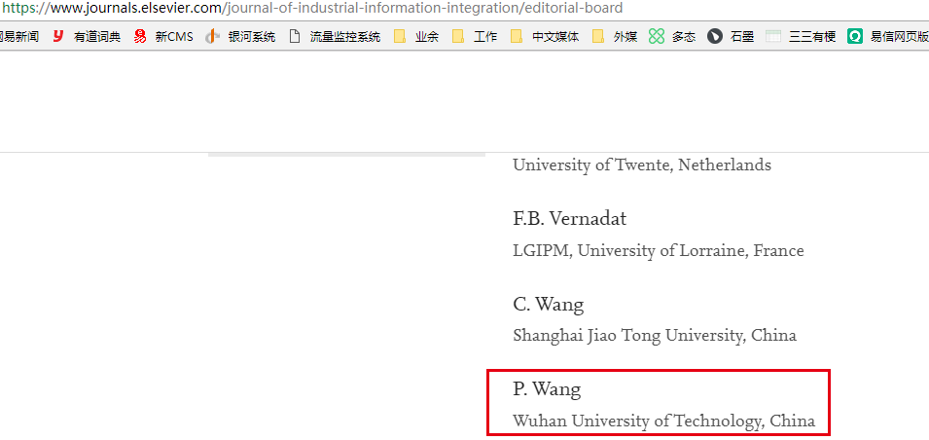

*** CONFENIS2018组委会名单中的王攀资料截图

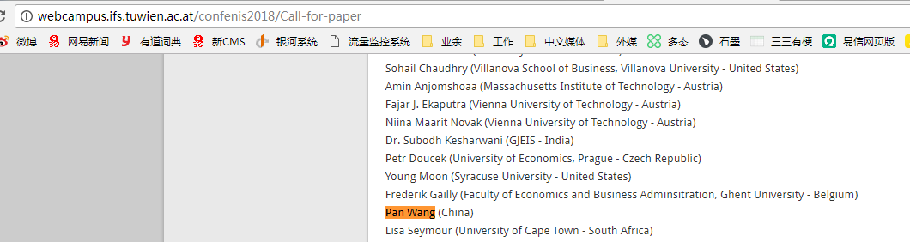

****邮件正文翻译

IEEE信息系统技术委员会共同主席，

Industrial Information Integration期刊主编，

2018CONFENIS会议组委会主席，

我是一名武汉理工大学校友/关注此事的中国公民。我写该邮件是为了提醒你们武汉理工大学教授王攀，是一起导致研究生陶崇园自杀的权力滥用案件的被调查对象。为了贵组织的声誉，我真诚地建议你们暂停和王攀任何形式的合作，直到王攀的案件得到公平透明的调查。

下面是媒体关于此事的报道：

【描述事件前后经过的媒体报道，鉴于大家比较了解就不再重复翻译了】

4月8日，武汉理工大学校方在微博上发布了情况通报，并声称王攀仅“有一些和教学无关的活动”，只“停止了他的研究生招生资格”。受害者家庭认为该通告“缺乏实质”，要求“取消他的教学资格”。

我深知中国学术圈里的习惯，即研究生入学时是一个导师，却只是挂名，最终需要为另一位导师工作。我担心这个漏洞会被王攀滥用，以做出他对受害者所做之事。因此，他任何继续的学术工作都会对他目前和未来的研究生产生风险。贵组织对他的停职就是通往正义的第一步。

既然校方不愿意取消他的教职，我强烈建议贵组织保持一贯的高道德水准，暂停与王攀的学术合作，直到他的案件被彻底、透明的调查处理。

我也听说有些外媒在跟进此事。我真诚地希望您为了贵组织的声誉做出正确的决定。

*这封邮件是#justicefortcy#系列行动的一部分，它可能是第一封但绝不是最后一封。我们为重复发邮件感到抱歉，但我们只有如此才能让我们的声音被听到。